Creating a Story-Driven Game to Explore Social Issues (Game Dev)

The GitHub → ​​<https://github.com/sniffleslou-lab/Comp3000_GameProject>

The trello → <https://trello.com/invite/b/68da76afd19be866ded2814a/ATTI1426f3256d8ab01e08da9104f3055edf789E18A7/comp3000projectf>

# Table of Contents

**Table of Contents 1**

**Introduction 3**

Pitch 3

Inspirations 3

Player Experience 4

Platform 4

Development Software 4

Genre 5

Target Audience 5

**Concept 5**

Core loop 5

Themes 6

Primary Mechanics 6

Dialogue and choices 6

Puzzles 6

Secondary Mechanics 6

Extra paths 6

Hints 7

Movement and interactivity 7

Tertiary Mechanics 7

Character customisation. 7

Collectables 7

Voice lines (doubtful of adding) 7

Story →first draft← 8

Characters 8

Dialogue 8

**Audio 8**

Music and Sound Effects 8

**Game Experience 9**

Controls 9

Menus 9

**Technical Requirements 9**

Systems [BASIC IDEA] 9

UI 9

Dialogue tree + Choices + Story flags 9

Scene interactivity 10

**Risk Plan Management 11**

Initial Risk Plan 11

**Legal, Ethical, and Social Constraints(develop) 12**

Legal Constraints 12

Copyright 12

GDPR 12

Hosting and platform regulations. 12

Ethical Constraints 12

AI uses transparency 12

Representation 13

Social Constraints 13

Accessibility 13

Culture sensitivity and inclusivity 13

**Project Vision 14**

# **Introduction**

## Pitch

An immersive 2.5D game that drops the player into interactive set pieces, allowing them to make choices that impact the story. These could be small consequences or perhaps big consequences.

Solving puzzles and talking to your friends is the only way to push the story forward.

## Inspirations

The visual inspiration is drawn from Anthology of the Killer, a 2.5D game that allows players to walk around 3D environments while creating set pieces and characters that appear 2D. The gameplay is inspired by games such as Life is Strange, Coffee Talk, and Disco Elysium. Player choice matters, and the gameplay core is tied into the story. 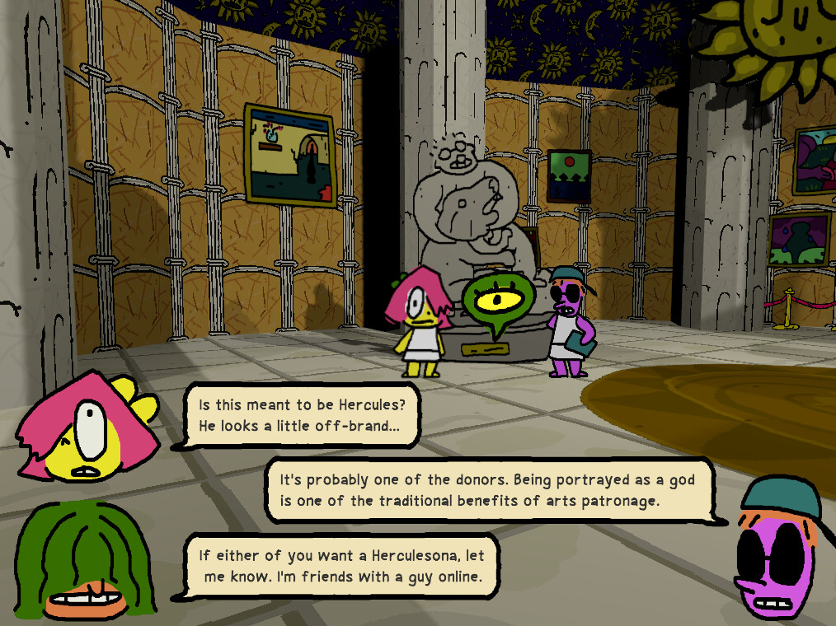

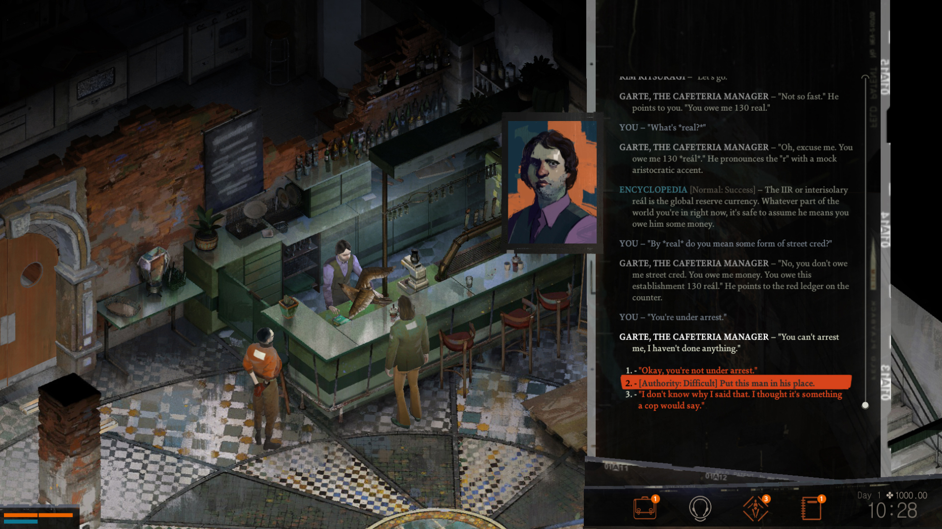

Disco Elysium

Anthology of the Killer

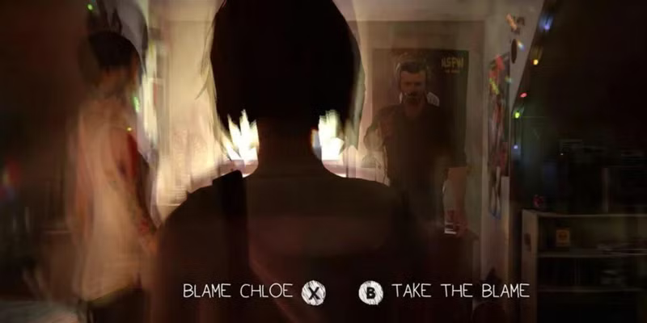

Life is Strange

Inspirations that aren’t games would be Pink Floyd – The Wall, I saw the TV glow with the ambience and overall feeling. A chronic mess of colours that makes the player feel dazed.

Book inspirations: Conversations with Friends, Convince Store Women and The Bell Jar

.

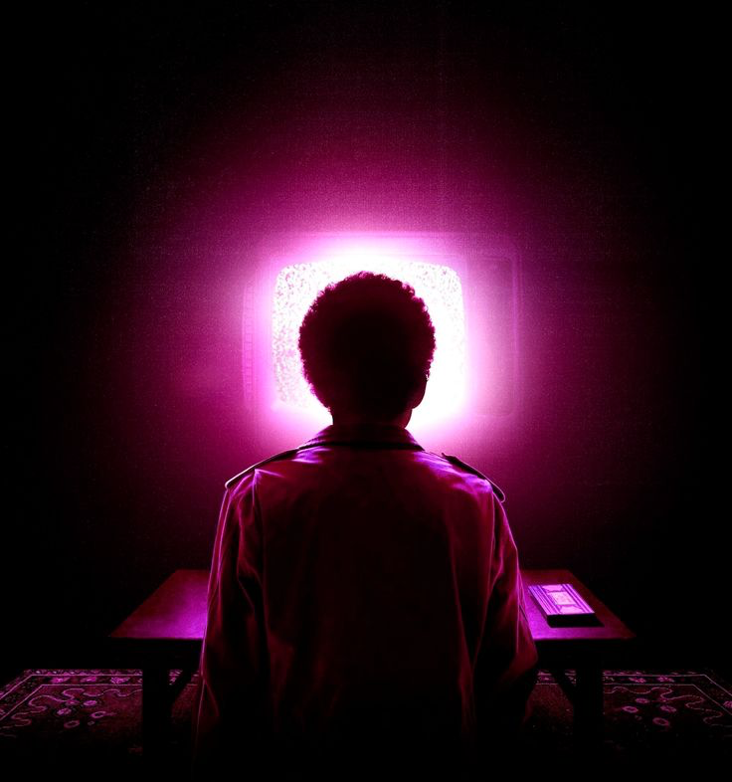

I saw the TV glow The Bell Jar

## Player Experience

The core experience is letting the player feel emotionally attached to the main character and the overall story. I want the player to feel uncomfortable. The project is creating a Story-Driven Game to Explore Social Issues, and social issues aren’t comfortable; the game should make the player aware and be uncomfortable with what is in front of them. Like in The Bell Jar, the experience of reading the book is difficult as we read a story of a young woman’s mental health rapidly declining. I aim to carry that feeling while making the game still enjoyable to play, but the story is difficult to get through.

A game example would be Pathological. A game where it takes the game out of the story, where the player isn’t a strong supernatural god but an average Joe in a village.

## Platform

The game will only be playable on PC, unless by the end of the project, before the deadline, if I have enough time by the end of the year. An attempt at porting the game to mobile or console could happen, but doubtful.

## Development Software

The game will be programmed in Visual Studio with C++.

The art will be created through Blender for the backgrounds, Clip Studio Paint for designs, and Aseprite for the set pieces/characters.

Sound effects would mostly be stock effects.

Music. I have connections to a couple of musicians whom I could commission to create musical pieces for the game.

## Genre

2.5D Adventure puzzle game with elements of role-playing, allowing the player to make choices.

## Target Audience

The target audience is adults aged 18-30, mature adults, due to the game tackling social issues.

These could be young adults who enjoy games with themes of social issues and coming-of-age stories, or even fans of young adult books who already enjoy reading stories with similar themes.

Players who enjoy games such as Until Dawn, Life is Strange, and The Walking Dead could find the game enjoyable.

Perhaps the visuals will bring fans of Undertale and Paper Mario due to a sense of nostalgia.

# **Concept**

## Core loop

A dialogue system where the player makes choices and chooses different lines on what to say to the NPCs. With an interactive environment. Players receive quests from said NPCs to further engage with them and the story.

A basic idea is this. When the player does a quest, their ‘friendship’ improves.

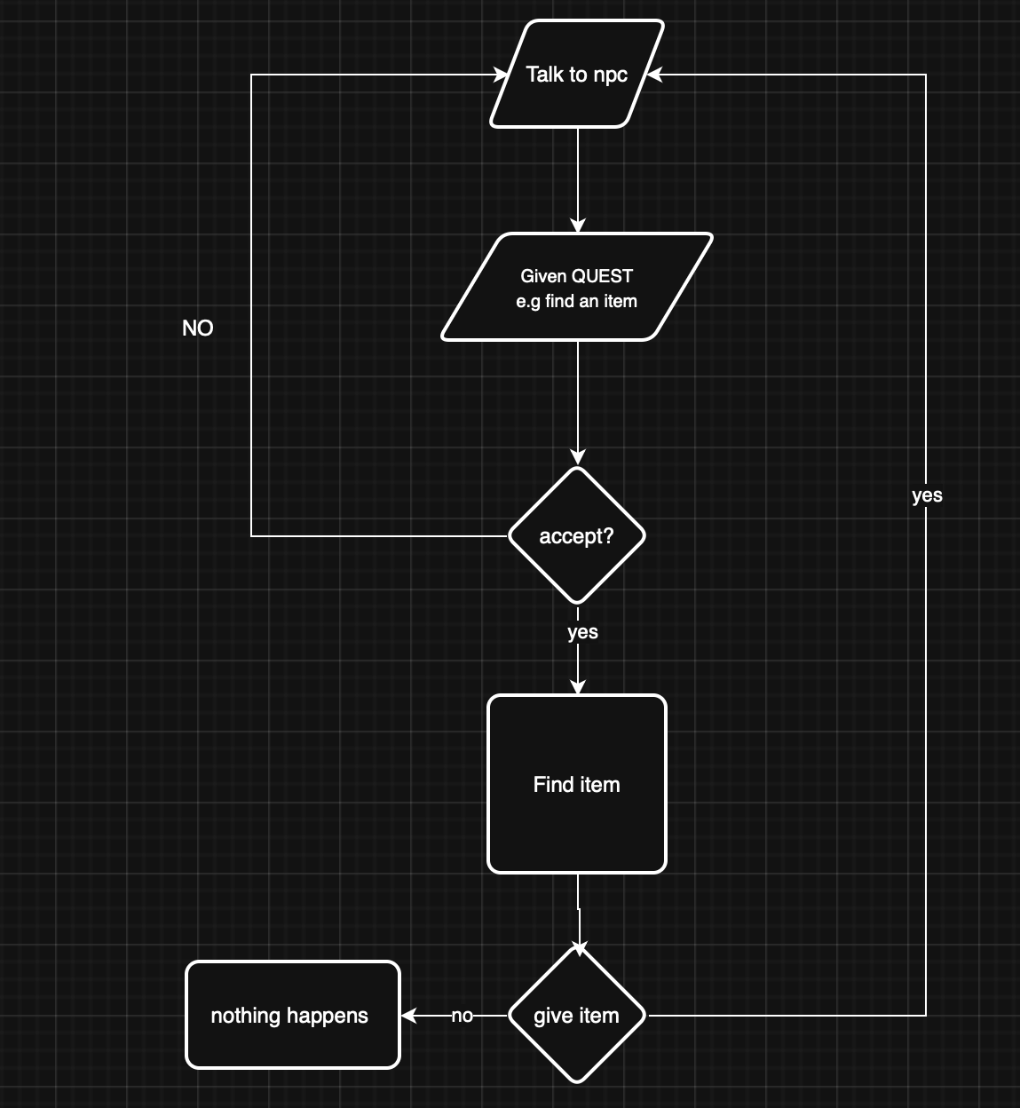

## Themes

Three social issues I want to cover in this game:

* Queer rights
* Mental health
* The rise of Alt-right beliefs in the country

All three can link to each other.

A running motif is the depersonalization of an individual, the fear of watching everything around you pass by, and the choking feeling of knowing things are getting worse, but ultimately, there isn’t much you can do.

Characters feel stuck, but their sense of community, like friendship, helps them work down a path.

Throughout the game, the threat of a force that the player can’t stop is approaching. An ideology that the player encounters through the design of levels and NPCs.

## Primary Mechanics

### Dialogue and choices

Depending on your choices, dialogue can change with NPCs. The character communicates with NPCS with select options, or just does not talk to them.

### Puzzles

The player will encounter big set pieces that require the player to solve an issue. They will have encounters with small optional puzzles that can change dialogue choices and that could change how the game ends.

Puzzles that allow the player to interact with the scene, moving objects across the room.

Using knowledge and items players require throughout the game, and interacting with past puzzles to unlock secrets.

Puzzles should make the player feel rewarded, and rewards should be dished out to drive in the player’s curiosity and engagement.

## Secondary Mechanics

### Extra paths

Not all puzzles lead down a single path; some puzzles have optional routes.

Hidden doors that the player can unlock by experimenting with the puzzles. Rewards could be secret collectables or items that players can get.

### Hints

The player can use hints to get a direction on what they are supposed to be doing or shine light on a puzzle that the player might be stuck on.

In a game, Crow Country. The player can use a hint to get insight into what to do or where to go; the disadvantage of this is that the player gets a lower score at the end.

Implementation of this feature could take place. A player could use hints, but at the cost of a score or an ending.

### Movement and interactivity

The player can move around and interact with the scene. The player can go up to a painting and have a better look at it, allowing the painting to pop up on the screen.

Interaction with set pieces of the scene could also be pushing objects for puzzles, or doing small tasks that help push the themes of the 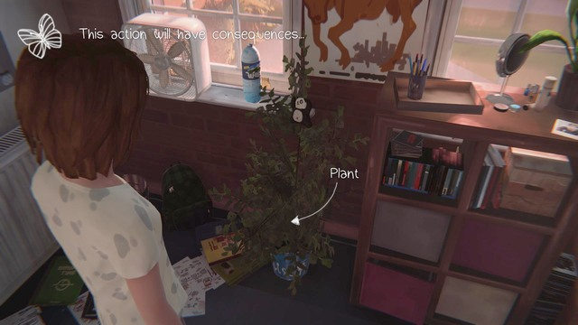story.

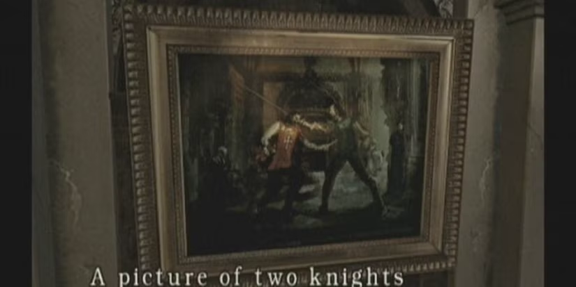

RE1 for GameCube 2002 Life is Strange

## Tertiary Mechanics

### Character customisation.

Players can change the physical appearance of the main character through clothes and hairstyles. These could be rewards depending on the ending or the additional secrets the player can unlock.

### Collectables

Small collectables, for example, ‘Riddler Trophies’ in the Arkham trilogy. Allow players to earn collectables, possibly completing mini-quests for characters or unlocking additional content.

### ~~Voice lines (doubtful of adding)~~

NPCs and player characters could talk. It would make the game accessible and engaging, but could backfire. Bad voice lines make bad writing more apparent. This could take the players out of the game, making it a bad experience for players.

## Story →first draft←

The story will be split into three acts using the typical story format.

Introduction –(Rise)-> climax -(fall)-> resolution.

The story/game takes place in a house (inspired by sitcoms that would have a bottle episode). Three characters the player can interact with and do quests for.

The story showcases the main characters' worries about the future, struggling in the backdrop of a country that hates them for something they cannot control.

Three characters are representations of their future.

The player completes the game after doing a series of puzzles and quests. Reconnecting with the NPCs.

## Characters

Three main NPCs

1. Optimistic. Thinking everything is going to be ok in the end.
2. The lost hope of society. They will mention leaving for a different country and mention giving up.
3. A guy who has fallen to hatred in the alt-right pipeline.

Further ahead in development, the more fleshed out they get, but above is just a general idea of who they are.

## Dialogue

Dialogue is through text. It’s doubtful that I could get voice actors. The text will be displayed through text boxes, with a little icon of the player/NPC's face on the side to help give clarity on who is talking at any given moment.

# Audio

## Music and Sound Effects

I plan for when a character text box appears, a sound plays that is meant to represent the character who is talking, and small sound effects to reflect the mood of the text. This will help immerse the player in the story. Example: Grunts and gibberish.

For music, I am unsure. I mentioned above that I am considering outsourcing the music to an artist I know.

The use of stock sound effects will be played when an event is triggered.

# Game Experience

## Controls

W, S, A, D for movement,

Right-clicking on the mouse for choices. Pick up items.

F for journal / quest menu.

## Menus

* Start screen
* Pause screen with options
* End screen

# Technical Requirements

Written in C++ through CLION.

## Systems [BASIC IDEA]

Since it's written in C++, the use of established frameworks such as OpenGL.

An idea of the micro systems that tie into themselves for the project:

### UI

Since the game visuals haven't been decided yet, I can’t really give a clear idea of what the UI would be like.

Here is a rough idea of what the text boxes will look like.



Since the game is dialogue-heavy, I don’t plan to add a health bar or anything that pops up to the player. Although if the player does lose heath, it would be more reflective through the character sprite.

The game will have a menu and options.

### Dialogue tree + Choices + Story flags

The dialogue tree will be built using arrays and json files, using story flags to trigger further lines. For example, it will cycle 1-3 when the trigger line 4, you would need to complete a quest after completing, you would trigger line 4-6. Will make use of service locators to play certain noise and sound effects when an event happens.

### Scene interactivity

For scene interactivity, my first idea is to apply the event queue pattern to the scene interactivity when it comes to examining items and the scene.

Moving stuff around for puzzles will mean applying physics to an item.

# Risk Plan Management

## Initial Risk Plan

( 1= low / 5= extremely high)

| Risk | Management Strategy | Likelyness | Impact |
| --- | --- | --- | --- |
| Subject knowledge | The first two weeks (The first sprint) will be learning and gaining the baseline knowledge needed throughout the project life, even though the first two weeks are for researching, gaining resources with academic books, videos, etc.  These two weeks and possibly days of extra learning and additional knowledge could halt the project. Another aspect is that the research could be obsolete.  For example, C++ is a language that receives updates; I could use an outdated resource, using C++ 2014, while I am using the modern version of C++. | 3 | 5 |
| Personal issues | I could encounter personal issues that could prevent work from being done on the project, which could lead to the project being set back. | 2 | 4 |
| Scope creep | I am writing my own engine and game; this is a big undertaking for anyone, and I have to be careful with my planning and the ideas I choose to add. Failure could lead me to encounter scope creep, resulting in the project going behind schedule. | 2 | 4 |
| Loss of data | The project’s code could be corrupted or somehow gone missing. To avoid this, the usage of GitHub as a way to always have a backup and a set version control would mitigate the risk.  Although GitHub is being used, other forms of backing up data will be employed, either through OneDrive or a physical hard drive. | 1 | 5 |
| Time management | Time management is structured through Agile. The time frame is usually covered in sprints. So, in theory, time management should be under control. | 2 | 3 |
| Debugging Complexity | Due to the nature of story flags and dialogue systems, debugging could be complex, especially since the program is built in C++. This means, unlike Unity, that displays detail on why a scene won’t work, that just won’t be the case. | 4 | 3 |
| Asset dependence | An issue that could occur is waiting for an asset to be created.  I plan to use placeholders throughout the project. | 2 | 2 |

# Legal, Ethical, and Social Constraints(develop)

## Legal Constraints

Discussing the legal side of the development and production of the game, there are multiple things to consider.

### Copyright

The plan for the product is to outsource some resources to artists, like the music. So they would own the copyright, but small parts of the game as well, such as open source frameworks like OpenGL that have licensing attached and fonts.

The project should take into account the agreements that are attached to assets and the licensing that is needed.

Failure to do these could result in laws being broken and possibly fines being applied to me as the sole developer.

### GDPR

The game shouldn’t take any personal data or store it, but if the scope changes, conditions should be considered for the implementation. Failure to meet these regulations will result in fines that could negatively affect the project.

### Hosting and platform regulations.

Many sites/programs, such as Steam, have rules that I have to follow when publishing, for example, making AI use transparent to the customer.

## Ethical Constraints

In this section, I will discuss the ethical constraints of the project that are likely to occur throughout and afterwards.

### AI uses transparency

With AI being used to write code, create art and music, it's important to declare these when releasing the final project. Steam, [itch.io](http://itch.io) has rules about declaring and even using AI in games. If any AI is to be used throughout the project, it is important that a declaration is made. Without it, regardless of regulations on hosting services, there is still a need to be mentioned.

The use of AI is also an important piece that needs to be discussed further. AI art, music and writing are trained by stolen works without credit, in many ways. Using AI could be seen as a form of plagiarism.

### Representation

Due to the nature of the project being ‘Creating a Story-Driven Game to Explore Social Issues’. Representation must be done with care. Failure could lead the target audience to feel isolated.

It’s important that the target audience feels like the representation is not ‘bad’. Although bad representation is different to ‘bad characters’. Characters can be written to represent a culture, gender or sexuality, but be ‘bad’ or ‘messy’. Representation should aim to make the characters feel like actual people.

## Social Constraints

### Accessibility

Discussing the social aspect of the document for the project, there are a few considerations that need to be taken before, during and after the development.

The dialogue will be presented in text format, so it’s important to make sure the text is accessible for those with visual impairment.

So, for example, choosing a font that people with dyslexia can read, or allowing players the ability to change the colour of the text.

### Culture sensitivity and inclusivity

Due to the nature of the topic of the project, ‘social issues’. I have to be careful on how I portray these issues; the overall plan is to go into the project with care and take from my experience, but also the experiences of others. Failure to portray these issues with care and empathy could make the player experience bad feelings.

This goes along with inclusivity. Failure could make the game feel outdated, and could mean failure as a product.

# Project Vision

* For [who?]
* Whose [problem]
* The [name of your product]
* Is a [Type of product]
* [What are the key reasons?]

# 